Creating a new GitHub Repository on local Desktop :

1. Create a New Repository on <https://github.com/new>
2. Get the URL ( For testing I have created <https://github.com/vrs-learn/newGitTest> )
3. Now go to a local directory on Windows on cmd ( where you want the Repository to be created ) and run the command :

>git clone <https://github.com/vrs-learn/newGitTest.git>

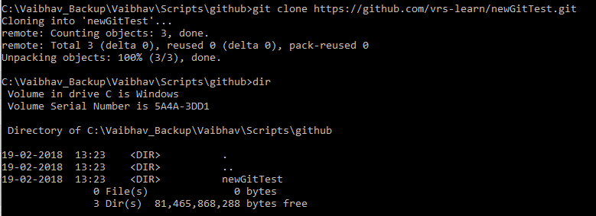

If you see above the repository is created under the github directory on local computer “newGitTest”

If you do a dir command, you can see the README.md file of the repository :

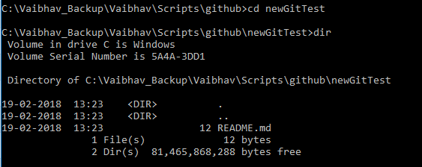

1. Now I created a file index.html and saved it in this directory
2. Once the file is saved , run the below command . It shows the new files which are created.

>git status

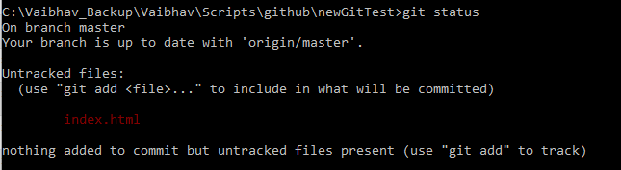

1. Now to add the file into the git repository , run the below command :

>git add index.html

Once ran, again run the command :

>git status

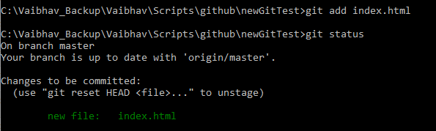

The above output shows the file index.html was added to the local repository .

1. Now we have to commit the changes to local repository . Run below command :

>git commit -m “Created the index.html”

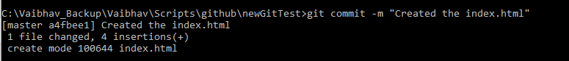

-m is used to put some message about the commit being done.

1. Now, to push the changes to the github, run below command :

>git push

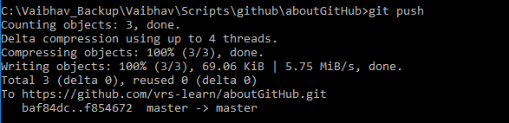

To PULL data from the repository :

1. Use below command for pulling data from the github repository :

>git pull

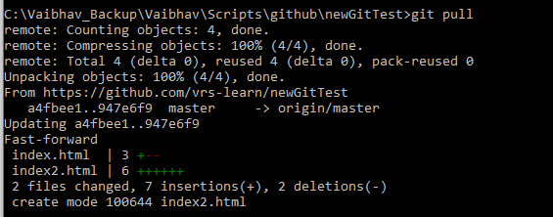

If there are multiple files to be added to local repository :

1. Use below command :

>git add .

Or

>git add -A

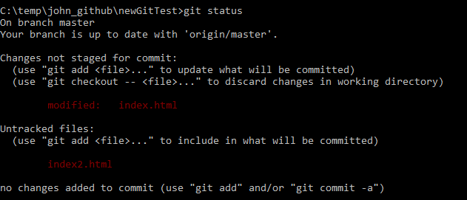

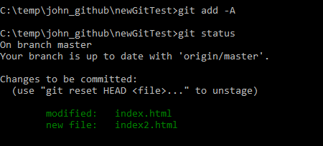

Then again commit and push.

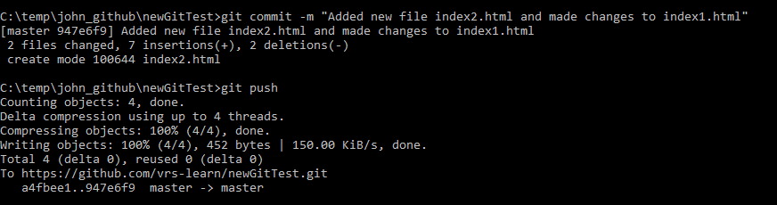

**GIT CONFIG :**

Setting up a User name for the Git commits :

**To set the user name Globally for all commits done from your local computer :**

>git config –global user.name “Vaibhav Saxena”

To confirm the changes :

>git config –global user.name

**If you want the user name for a specific git repository :**

Go to the working directory of the repository :

>git config user.name “Vaibhav Saxena”